HUMAN-MACHINE INTERACTIVE INTERFACE DESIGN INVESTIGATION OF
WEBGIS INTROJECTED WITH VISI
XIONG Lan¹ DU Qing-yun² HU Hong-liang³ HUANG Mao-jun⁴
(1 School of Resources & Environment Science, Wuhan University, China, E-mail: worldgisxl@163.com
2 School of Resources & Environment Science, Wuhan University
3 Shaoxing County Surveying and Mapping Department
4 Jiangxi University of Finance Economics)
Abstract:
Facing the large number of WebGIS products, it is important to make a brilliant interface for serving the users. For the first time, this paper brings forward a new attempt of WebGIS interface design introjected with VISI, which is shorted for Visual Identity System Internet.
Visual Identity (VI) is one part of Corporate Identity. It is a design system used to propagandize the culture of the corporate built on the management methods, market area and manufacture target.
Developing with the internet technology, VI gradually turns into the VISI, whose intent is using the network to spread abroad the corporate information. As a design theory, VISI is unlike the computer technology which employs models, formulas, arithmetic to describe itself accurately but it is partly similar to the psychics, abstract and applied. VISI includes abundant elements; among them some familiar essential ones are: text, background color, buttons, charts, forms, navigation tools, images, videos, dialog boxes, background music, etc. And what’s more, using the Plug-in will be helpful to deposit more different formats of multimedia data.
Introjected with VISI, WebGIS design is needed to consider lots of factors: the color should consult the aesthetics and assort with the map; the text may as well be concise because of the leading map; images should not dispute the map; It is also crucial to use the same style through the whole system and so on. In one word, VISI provide design elements and frames of references for the WebGIS.
Wuhan Bus Information Query System is a formal WebGIS system promulgated by the government. This paper also shows the design result of the system which introjected with the VISI. This is a new design attempt of WebGIS interface.

Keywords: VISI, Visual Identity System, WebGIS, Human-Machine Interactive Interface Design

About The Author: Xiong Lan, Ph.D candidate. Her research interests include WebGIS and geography information engineering. Her achievements are Wuhan bus information query system, Wuhan multimedia map CD, Jiaxing multimedia map CD, Xinjiang water pipe network management system. E-mail: worldgisxl@163.com
0 Introductions
CI (Corporate Identity) is brought by an American designer at first in 1930 and now has come into being an integrated theory. It usually includes three parts: VI (Visual Identity）, MI (Mind Identity) and BI (Behavior Identity) ^{[1]}.
Facing the high developing technology of the web, the VIS (Visual Identity System) which is used for enterprise visualization drumbeating is slowly spreading to the internet area and now has given a new name called VISI (Visual Identity System Internet) ^{[2]}.
The foremost intention of VISI is to propagandize the enterprise’s information, and WebGIS is also a very important way to promulgate the geographical information. Nowadays, WebGIS usually thinks much of the expression of geographical information and the achievement of the basal arithmetic, but it always ignores the design of the human-machine interactive interface.
Dr. Chen who is working for CAS (Chinese Academy of Sciences) has denoted that: from the point of view of map design, now most of the internet map design more or less has exist some problems, because the internet map design is always finished by some computer companies and has few technician of map, a lot of the internet map are not satisfactory to the users ^{[3]}.
Following the drastic development of GIS industrialization, it is becoming very necessary to use the professional design knowledge to guide the GIS technician to take over the design assignment of WebGIS. Applying the theory and experience of VISI into the WebGIS design, on the one hand we can achieve the design of human-machine interface efficiently; on the other hand we can supply the use with better information service.

1 About VISI
VISI comes from VIS (Visual Identity System). The base of VIS is the enterprises’ management means, prosecution principle, manufacture intention and so on. VIS is a tool used to spread the information of enterprise abroad by vision ways. The VISI comes into being while the VIS introjects with the internet technology.
Now，VISI usually appears in the form of website. All elements in the website such as pictures, texts, flashes and the arrangement of these elements are a part of VISI design. In other words, the color, typeset and other things in the website will give human an apperception, the apperception effect can be designed by VISI.

2 Combinations of WebGIS Interface Design and VISI
WebGIS is a production which combines the internet and GIS and it is one of the approaches to realize GIS platform transcend different areas and systems. The present WebGIS application system always can be separated into two kinds: one which is based on Server-Side application system and the other one which is based on client-side application system.
In the two kinds of WebGIS, whichever we choose, we will always face the interface of the browser directly. For improving the efficiency of the WebGIS and enhancing the interface attraction of the system, it is worthy to think about the introjection of the WebGIS and the VISI. The VISI can bring a lot of design elements and principle to the WebGIS.

2.1 VISI Supply WebGIS Interface Design with Basal Principle
Both the methods and theory of VISI attach importance to the recognition of the users, so based on the thinking “consider as the users”, WebGIS interface design is commended to have these characters as follows:
(1) Scientific
All contents in the WebGIS may as well be scientific. The interface of WebGIS fronts the users at first hand. If the contents are false or outdated, especially the geographic information, the WebGIS will hardly fulfill the request of the users, and even worse let the users make mistakes. To be scientific is the first important principle of the WebGIS interface design.
(2) Intuitionistic
Many users of WebGIS are laypeople in GIS, so it is hard for them to find out which function exactly some or other button has. The design of the WebGIS interface should be intuitionistic, that means the buttons or other things should make users feel easy to use it and like to use the system again.
(3) Alternating
Being alternating means that the system should make users feel the system serves them all the time in spite of the wrong operation.
There are two kinds of alternating tools: user-to-system and system-to-user.
User-to-system tools include the tools that are used by users to communicate with the system. Nowadays the tools always contain four familiar types:
Keyboard answered type--very familiar type, such as keyboard shortcuts, input field and so on.
Mouse answered type--very familiar type, it has three subdivisions, clicking answered, rolling answered and suspending answered. Such as click to select an interested point, roll to zoom in the map and suspend on a tool’s icon for showing its help.
Touch answered type--such as an exhibitive system usually allows the fingers to touch the screen for searching information.
Voice answered type--developing with the voice identification technique, voice answered system will be more and more hackneyed.
System-to-user tools include the tools that are used by system to communicate with the user, such as the system loading clew.
(4)Harmonious
Interface design is better abstain from piles of contents out-of-order and primary-and-secondary matter undistinguished. So WebGIS interface design should also lay store by contents’ harmony, and the most important thing is the harmony of the structure.
A good WebGIS interface has clear structure. The functions of the system are easy to be found. Users use the system efficiently, then they will come to use again.
There are two points worth to be thought a lot of:
The first, the most important contents should be put in the well-marked place. The habit reading order of users usually is from left to right and from up to down. According to this point, in the "Wuhan bus information query system", the query function tools and the results are put in the left-up of the webpage.
The second, the area of the screen is limited, so we should divide the function area of the interface by the WebGIS system’s contents and aims. For example, in the "Wuhan bus information query system", because Wuhan is an old-line country, it has a lot of long and decussate roads. Therefore, we set the map area take up the 50% of the whole interface, in this situation, when the users zoom in the map, there is usually enough area to show the long road in the map. The users are convenient to know the roads and bus routes, and they needn’t to pan the map many times.
(5) Idiographic
More and more WebGIS systems are publicized to the ordinary people. It brings a new problem to the WebGIS producers that how to attract more and more users. It is a good idea to improve the system function, but the interface design of the system also can not be ignored, because an idiographic interface will impress people deeply. It is a challenge work to make an idiographic interface of WebGIS.
(6) Unitive
If there are many pages of the WebGIS interface, it is a good idea to choose analogous typeset, or background image, or button style, because that can increase the coherence of the whole system.

2.2 VISI Supply WebGIS Interface Design with Many Design Elements
Developing with the web technology, the theory and technique of the VISI design is becoming rich and colorful.
At present, the VISI design, including many forms and elements, can be generalized several basic forms as follows: letter, table, picture, background color, audio, video, alternating image, varied button, navigation tools and so on. WebGIS contains a great lot of location information and attribute information, synthetically using these elements can help to intercommunicate with users in flexible ways and to show the query results better. Thereinto, most browsers can display GIF\JPEG pictures and GIF89a cartoon. That means the browsers can show the elements without any added procedure or module. But some multimedia files (such as MP3), need download procedure to the local hard disk firstly, and then starts up to play with the relevant exterior procedure.
Furthermore, browsers can show more formats of multimedia files with plug-in procedure. Java Applet, which is a kind of smart procedure that write in java for the webpages of any operating system, is more flexible and compatible then the other plug-in procedures. Now java applet is being gradually used by WebGIS, and the "Wuhan bus information query system" is based on it.

2.3 VISI Supply WebGIS Interface Design with Idiographic Design Content
As a design theory, VISI is different from some computer technologies that use some kind of models, expressions and arithmetic to operate exactly. VISI is abstract and practicality.
WebGIS interface design Introjected VISI usually needs to pay attention to some aspect as follows:
The first is the color. VISI color design absorbs a lot of knowledge from optics, physiology, psychology and aesthetics, and it has become to form a huge theory. A good VISI design pays much attention to the harmony and characteristic. The hue, the purity and the light are the three basal elements of the color. About the hue, it is wise to choose the web standard color used for WebGIS, because this will be convenient to change the whole pages in the WebGIS using the HTML language. The web standard color usually has two expression ways: hexadecimal name and IE4 color name exist in advance. Such as [color=#ff0000] and [color=red] [/color]. About the purity and light, it is commended to choose them according to the map’s color when the map area is large.
The second is the text. Text is a popular method to express some things. VISI thinks much of the readability of the text. If the text was too small, too light to read, it will influence the reading efficiency. And if page was too wide or long to put in the screen area, it will also do the matter. WebGIS includes a large quantity of attribute information which is stored in the database. When the user query, the system produce the results to the users instantly. And the results usually are in the style of the text. It is recommended to use the CSS (Cascading Style Sheet) to display the text. CSS is born in 1998 by the WWWC (World Wide Web Consortium), and it has been supported widely since the WWWC updating it to the version 2.0. CSS can control the figure of the text which the HTML language can not dominate deftly, such as the location, font and so on. CSS can help the HTML to show many styles of the text.
The third is the picture. If the pictures are too big, too many or too blurry to read, it will affect the users’ comforts. WebGIS usually has an especial character: the map. Map is generally a big and important picture in the webpage, so it is unsuitable to put other attractive pictures around the map. Moreover, if the geographical information has its own copyright, it is wise to use some watermark in the map pictures to protect the map.
The fourth is the other media. WebGIS also can use some flash, gif and other plug-in procedure to increase the uses’ interest, but use too much of that will tire users and debase the use effect.
These four aspects above is just for one webpage only, VISI also emphasize the harmony of the whole system. So in a WebGIS system, it is good to use the same background color, typeset and so on. That will make the user feel that the WebGIS is elaborately designed and enhance the number of the falling-back users.

3 An Example
"Wuhan bus information query system" is an official issuance WebGIS by government department, actualized method is to use the Server-Side to stock Java Applet procedure and bus information database. When client visit the WebGIS interface, the system can make use of Java Applet procedure automatically and downloads the needed procedure and data to client-side. Then client-side will complete query and display the results. The WebGIS client interface is made by the language JavaScript，and the execution software is FrontPage. These language and software have many peculiarities such as self-contained abundant functions, simpleness and understandability, convenient maintenance and updated ways.
When we design the client interface, Introjected with the VISI theory, we design it as follows:
About the color: blue is a contractive color, its indication is stillness、limpidity and the color blue is easy to make users to think of the blue sky and sea and get feelings of elevation, profundity, clarity and coolness. Moreover, blue also indicates felicity and hope, it always has characteristic of intellect and is the color symbol of modern technology. So we select blue as the background color. Further more, the "Wuhan bus information query system" will be opened in summer in due form, so the cold color blue can also be felt cool.
About the text: for reading character easily, page layout uses technique of CSS in the system. So in despite of the different size of the screen, the figure of the text is always the same.
About the picture: a welcome interface will commonly be shown before loading map in WebGIS. The welcome interface can show the content introduction and applying area of the WebGIS. And it can also increase users’ interesting in addition, add interface attraction. For giving prominence to the map area, there is no conspicuous picture in the system main interface.
About the other media: in the browser interface, java applet plug is used to display map. In the initializing period, java applet procedure will stay in Web server, which is a section of executable codes. HTML will use <APPLET> label to capture and catch it. Java applet can finish deciphering the GIS data and analytic function.
About the harmony: we choose the blue color as the main color, so the welcome interface, main interface, input interface for query information and output interface for query result more or less use the blue color. These make the WebGIS system seems like a harmonious whole.
Fig.1 to Fig.5 is the interface of the “Wuhan bus information query system”.

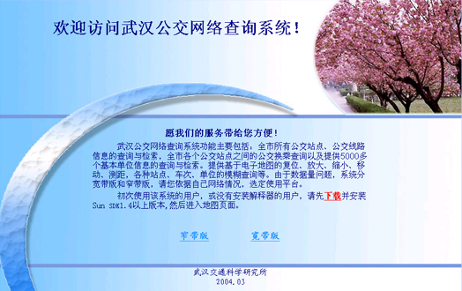
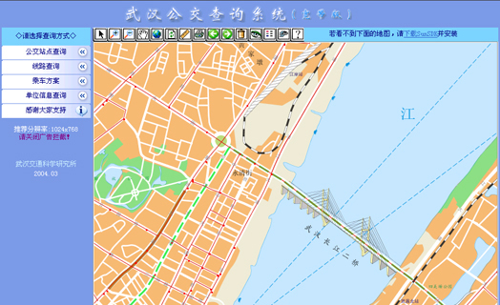
Fig.1 Welcome Interface
Fig.2 Main Interface

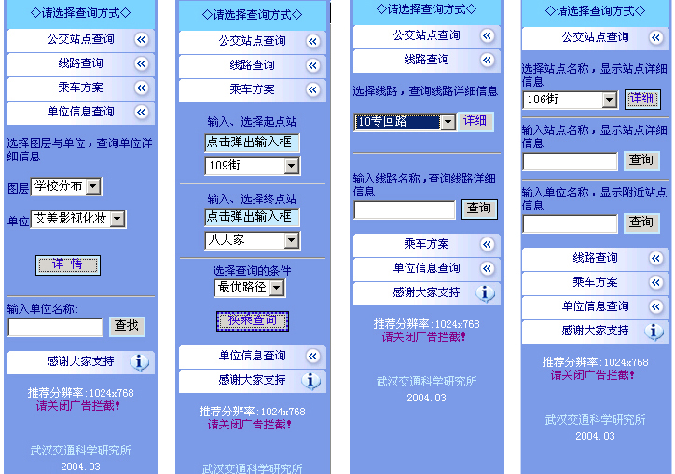

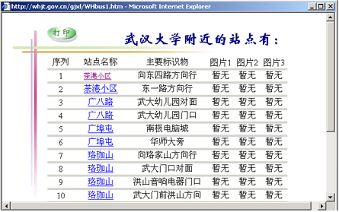
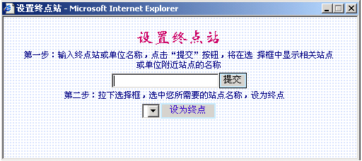
Fig.5 Output Interface for Query Result
Fig.4 Input Interface for Query Information
Fig.3 Interface of Query Menu

4 Conclusions
There is an experiment of WebGIS interface design Introjected VISI above. And the practice makes know that VISI theory is helpful to advance the WebGIS interface design art effect and practicality value. Of course, we need to say, there is no machine-made design principles. So when we use VISI to design the WebGIS, we should consider idiographic circumstances and take actions that suit local circumstances.

References:
[1] Zhang Mao-lin, Wu Dong-ming. Chinese CI Design System [M]. Shanghai, Tong-Ji University Publishing Company, 1997.
[2] http://www.designcool.net，2005.
[3] Chen Yu-fen, Liao-Ke, Jiang-Nan. The Principle of Internet Map Design [J]. Progress in Geography, 2001, 20(10): 78-87.
[4] Zhao-Hai, Zhang Qing-rong. CI and Aesthetics [M]. Beijin: China economy Publishing Company, 1998.
[5] Zheng Ji-fang. CIS: Corporate Visualization Design and Civilization Management [M]. Beijing: Petroleum Industry Press, 1995.
[6] Boston, Mass. Corporate identity: making business strategy visible through design. Harvard Business School Press, 1990
[7] Liu Xin-gui, Sun Qun, Ma Xiao-qing. Some Aspects about Enhancing the Electronic Map Expressive Force [J]. Modern Surveying and Mapping, 2004, 27(4): 19-21.
[8] Qi Qing-wen, Chi Tian-he, Liao Ke, etc. The Design and Production of Chinese Nature Atlas E-journal, 2001, 20(10): 40-45.

